
Machine Learning
Assignments

Submitted By:
Group Members:
Muhammad Hammas (051)
Mahnoor Fatima (059)
Mashaim Noor (036)

Submitted To:
Sir Shahzad Dar

Table of Contents
Brain Tumor MRI Prediction Assignment 1 (Logistic Regression) 3
1. Introduction 3
2. Objective 3
3. Dataset 3
4. Data Preprocessing 3
5. Model Implementation 4
6. System Working 4
7. Output 4
8. Libraries 5
9. Conclusion 5
Brain Tumor MRI Prediction Assignment 2: (KNN, Decision Tree, and Naive Bayes) 6
1. Introduction 6
2. Objective 6
3. Dataset 6
4. Data Preprocessing 6
5. Model Implementation 6
6. Model Evaluation 7
7. Best Model Selection 7
8. Confusion Matrices 7
9. System Interface 7
10. Confusion Matrices Graph With Accuracy 7
11. Output 8
12.Libraries 9
13. Conclusion 10
Assignment 3: Sentiment Analysis using Pre-trained Hugging Face Model 10
1. Introduction 10
2. Objective 11
3. Model Used 11
4. Working 11
5. Interface 11
6. Output 11
7. Libraries 13
8. Conclusion 13

Brain Tumor MRI Prediction
Assignment 1 (Logistic Regression)

1. Introduction
In this assignment, we developed a system to detect brain tumors using MRI images. The system uses machine learning techniques to classify images into two categories: tumor and non-tumor. Each image is processed and analyzed so that the model can understand patterns in the data. For this purpose, the Logistic Regression model was applied, which learns from the training data and then predicts the result for new images. This approach helps in making the detection process automatic, fast, and more reliable.

2. Objective
The main Purpose of this assignment is to build a machine learning model that can predict whether a brain MRI image contains a tumor or not. The model is trained on a dataset of MRI images so that it can learn the difference between tumor and non-tumor cases. After training, the model is used to make predictions on new images. This helps in understanding how machine learning can be applied in medical image analysis to assist in faster and more accurate decision making.

3. Dataset
The dataset used in this assignment was obtained from Kaggle. It is a Brain Tumor MRI dataset that contains medical images of the human brain. The dataset is divided into two main categories: 'yes', which represents images that contain a tumor, and 'no', which represents images without a tumor. Each image is labeled according to its category, which helps the model learn the difference between tumor and non-tumor cases. These labeled images are then used to train the machine learning model, and a portion of the data is used for testing to evaluate how well the model performs on new, unseen images.

4. Data Preprocessing
Before training the model, the images were processed to make them suitable for machine learning. First, each image was converted into grayscale to reduce complexity and focus only on important features. Then, all images were resized to 64x64 pixels so that they have the same dimensions. After that, each image was flattened into a one-dimensional array so it can be used as input for the model. Finally, the pixel values were normalized between 0 and 1, which helps in improving the model’s performance and makes the training process more stable.

5. Model Implementation
Logistic Regression was used as the classification algorithm in this assignment. The dataset was divided into two parts: training data and testing data. The model was first trained on the training data so that it could learn the patterns and differences between tumor and non-tumor images. After training, the model was tested on unseen data to evaluate its performance. This step helps in checking how well the model can make accurate predictions on new images.

6. System Working
A Flask-based web application was developed to allow user interaction with the system. In this interface, the user uploads an MRI image through a file input option. Once the image is uploaded, the system processes it by converting it into the required format and preparing it for prediction. The processed image is then passed to the trained machine learning model, which analyzes it and predicts whether the image contains a tumor or not. Finally, the result is displayed on the screen, making it easy for the user to understand the prediction.

7. Output
The following screenshots show the output of the system:
Figure 1: Tumor Detected
In this figure, the user uploaded an MRI image, and the system processed it using the trained model. After analyzing the image, the model predicted that the image contains a tumor, and the result “Tumor Detected” is displayed on the screen.

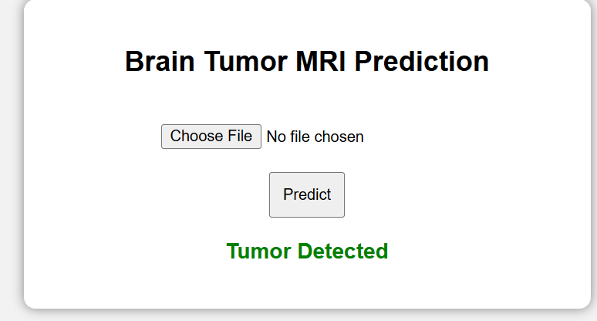

Figure 2: No Tumor
In this figure, another MRI image was uploaded by the user. After processing and analysis, the model predicted that the image does not contain a tumor, and the result “No Tumor” is shown on the screen.
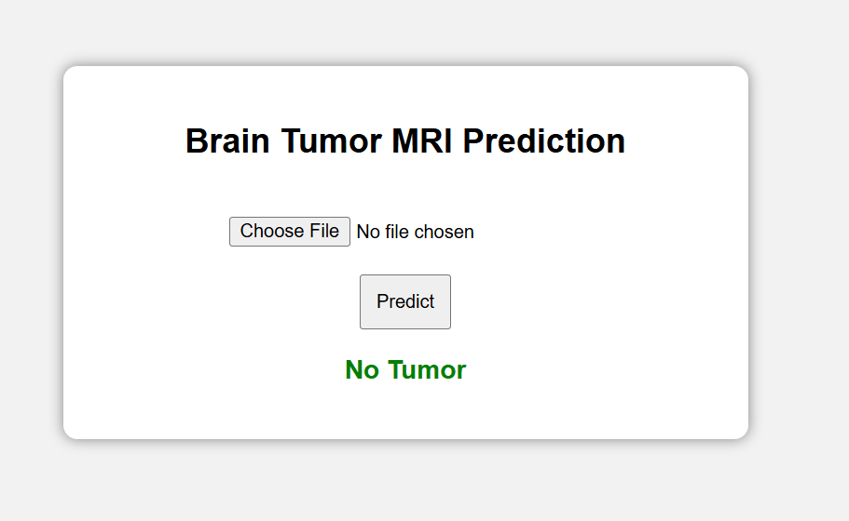

8. Libraries
Flask: Used to create a web interface for uploading images and displaying prediction results.
Pickle: Used to save and load the trained Logistic Regression model.
Cv2 (Open CV): Used for image processing such as reading, resizing, and converting images to grayscale.
Numpy: Used to convert images into numerical arrays for machine learning model input.
OS: Used to access dataset folders and read image file paths.
sklearn (Scikit-learn): Used to build and train the Logistic Regression model and evaluate its performance.

9. Conclusion
This assignment shows that Logistic Regression can be effectively used for image classification tasks. The model learns from MRI images and is able to predict the presence or absence of a tumor. It also highlights the use of machine learning in solving real-world problems like medical diagnosis. Moreover, the web interface makes the system simple, user-friendly, and easy to interact with.
____________________________________

Brain Tumor MRI Prediction
Assignment 2: (KNN, Decision Tree, and Naive Bayes)

1. Introduction
This project focuses on predicting brain tumors using MRI images. Machine learning techniques were applied to classify images into tumor and non-tumor categories. Three different models were used and compared to find the most accurate one. This comparison helps in understanding which model performs better for this type of medical image data.

2. Objective
The main goal of this assignment is to build and compare three machine learning models and identify which one performs best in detecting brain tumors from MRI images. It also aims to understand how different models behave on the same dataset.

3. Dataset
The dataset consists of MRI images divided into two folders: "yes" for tumor images and "no" for normal images. These labeled images help the models learn the difference between tumor and non-tumor cases. The dataset is used for both training and testing the models.

4. Data Preprocessing
To prepare the data, all images were converted into grayscale format and resized to 64x64 pixels so that all images have the same size. Each image was then flattened into a one-dimensional array to make it suitable for machine learning models. The pixel values were also normalized, which helps improve model performance and stability.

5. Model Implementation
The following models were implemented:
- KNN: Uses nearest neighbors for prediction. Best parameters included 7 neighbors and distance-based weighting.
- Decision Tree: Uses a tree structure for decision making. Best depth was 10 with gini criterion.
- Naive Bayes: A probability-based model with var_smoothing = 1e-09.
Each model was trained separately to compare their performance

6. Model Evaluation
The models were evaluated using accuracy, precision, recall, and F1 score. These metrics help in understanding how well each model performs in detecting tumors correctly.
Model | Accuracy | Precision | Recall | F1 Score
KNN | 0.9469 | 0.9705 | 0.9583 | 0.9644
Decision Tree | 0.9031 | 0.9409 | 0.9292 | 0.935
Naive Bayes | 0.8719 | 0.927 | 0.9000 | 0.9133

7. Best Model Selection
Based on the evaluation metrics, especially the F1 score, KNN performed the best among all models. This means it gave the most balanced and accurate results.

8. Confusion Matrices
Confusion matrices were used to analyze the performance of each model in detail. They show how many predictions were correct and how many were incorrect for both tumor and non-tumor classes
KNN: [[73, 7], [10, 230]]
Decision Tree: [[66, 14], [17, 223]]
Naive Bayes: [[63, 17], [24, 216]]

9. System Interface
A web-based interface was developed using Flask. Users can upload MRI images and instantly get predictions from all three models along with the best model result. This makes the system easy to use and interactive.

10. Confusion Matrices Graph With Accuracy
This figure shows the performance of three models: KNN, Decision Tree, and Naive Bayes using confusion matrices and accuracy metrics. The confusion matrix helps to understand how well each model predicts tumor and non-tumor cases.
From the results, KNN achieved the highest accuracy (94.69%) and F1 score, which indicates better overall performance. Decision Tree performed moderately, while Naive Bayes showed the lowest accuracy.
Overall, KNN is the best model as it provides more correct predictions and fewer errors compared to the other models.

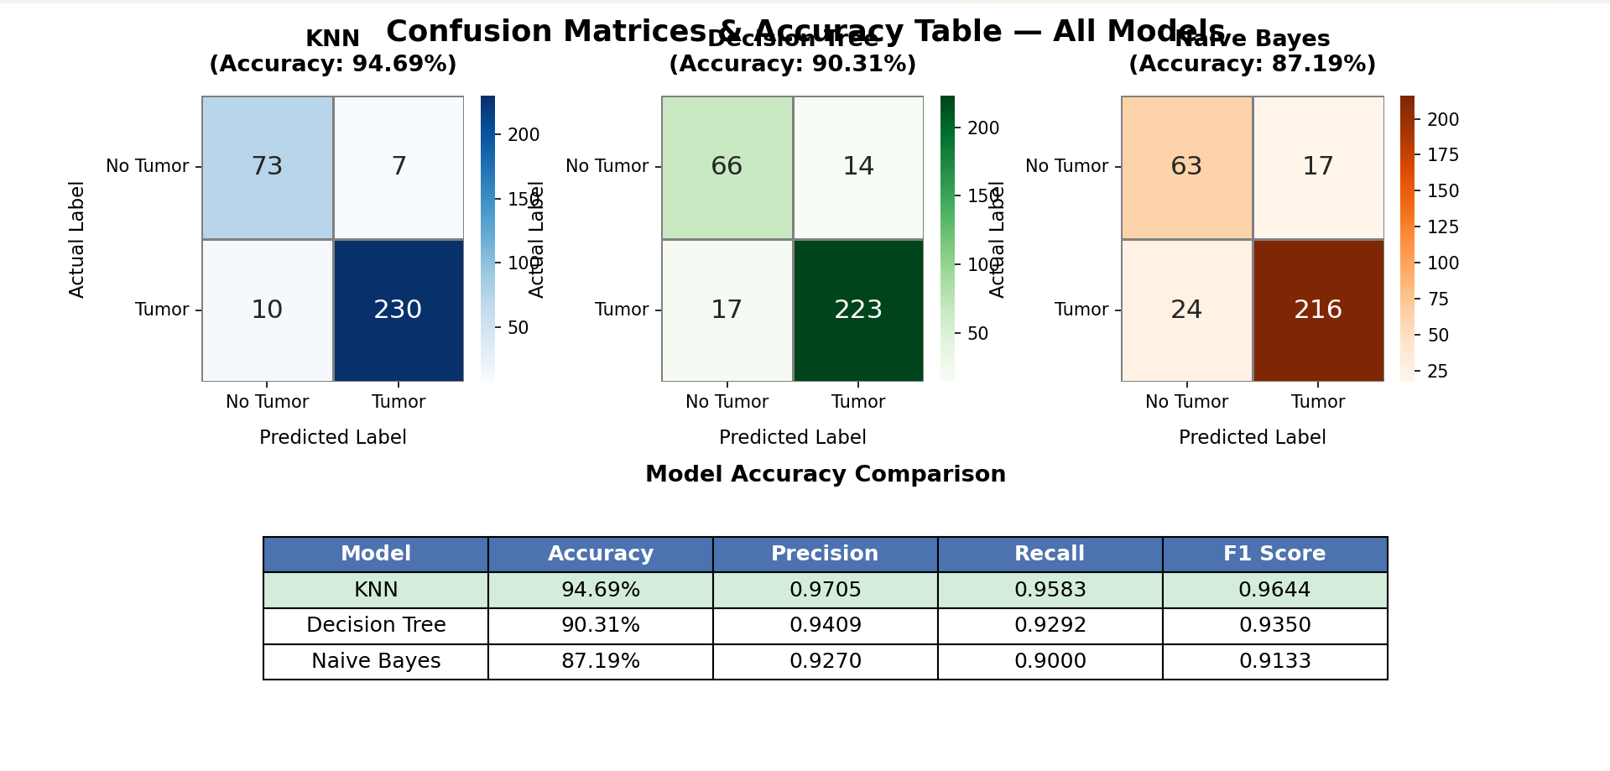

11. Output
The following figures show the working of the system:
Figure 1: Prediction Results and Model Metrics
In this figure, the predictions of all three models are shown for a given MRI image. Each model predicts whether the image contains a tumor or not. The best model result is also highlighted. Additionally, performance metrics such as accuracy, precision, recall, and F1 score are displayed, which help in comparing the models.

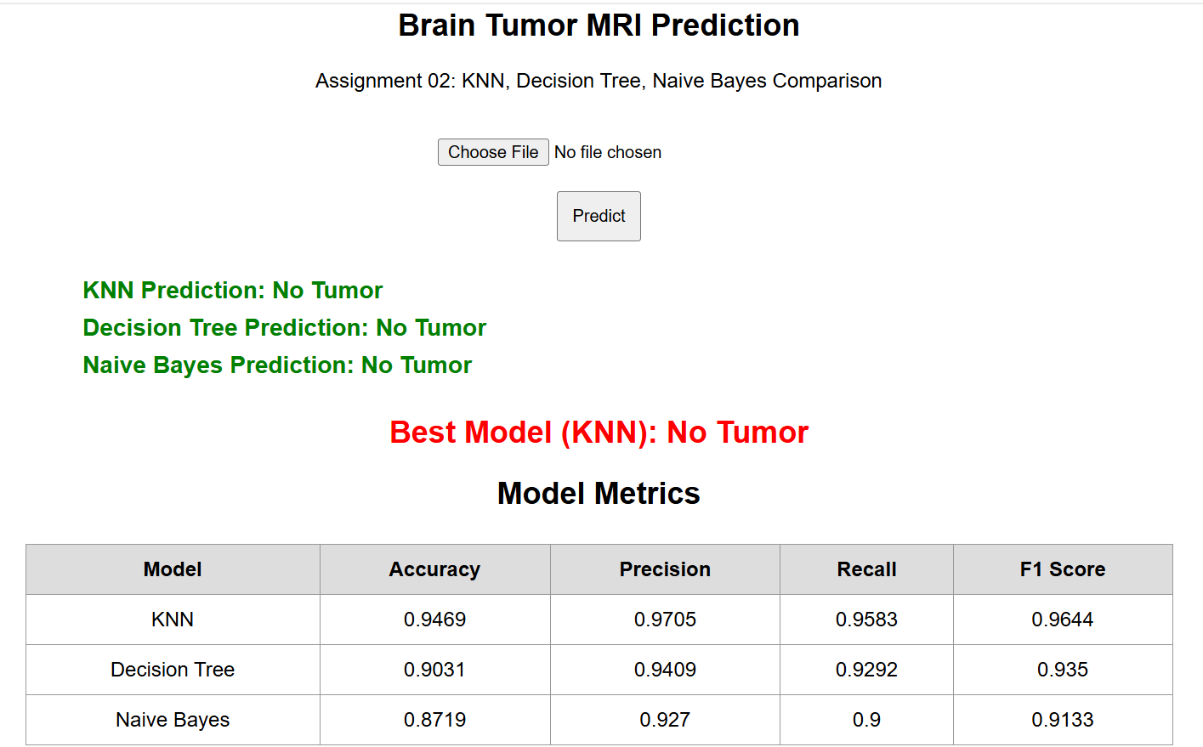

Figure 2: Confusion Matrices
In this figure, the confusion matrices of all three models are displayed. These matrices show the number of correct and incorrect predictions made by each model. It also includes the best parameters used for each model, giving a deeper understanding of their performance.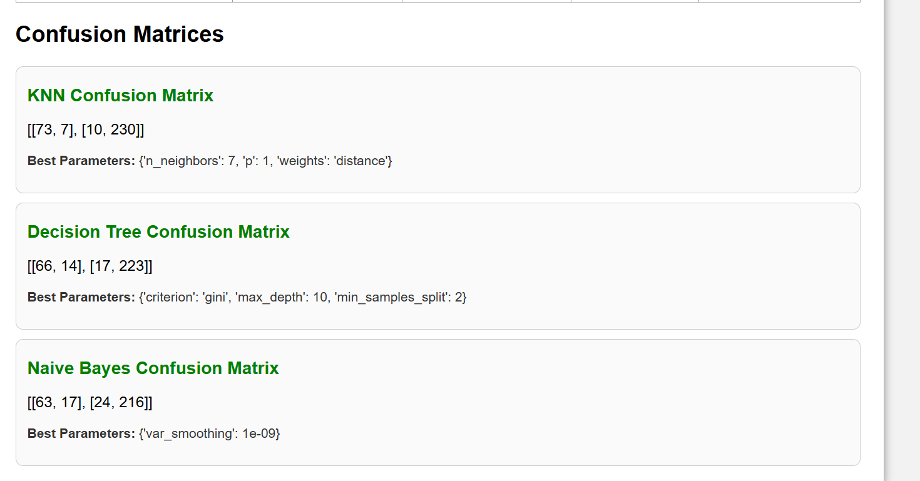

12.Libraries
os: Used to access dataset folders and read image file paths.
cv2 (OpenCV): Used for image processing such as reading images, resizing, and converting to grayscale.
numpy: Used to convert images into numerical arrays for machine learning input.
pickle: Used to save trained models (KNN, Decision Tree, Naive Bayes) and load them in the interface.
json: Used to store and load model evaluation metrics like accuracy, precision, recall, and F1 score.
sklearn.model_selection: Used for splitting data into training/testing sets and performing hyperparameter tuning using GridSearchCV.
sklearn.neighbors: Used to implement the K-Nearest Neighbors (KNN) algorithm.
sklearn.tree: Used to implement the Decision Tree classification model.
sklearn.naive_bayes: Used to implement the Naive Bayes classification model.
sklearn.metrics: Used to calculate evaluation metrics such as accuracy, precision, recall, F1 score, and confusion matrix.
flask: Used to create a web interface to upload images and display predictions and model comparison.
matplotlib.pyplot: Used to create and display graphs and plots such as the confusion matrix visualization.
seaborn: Used to create attractive and easy-to-understand heatmaps for the confusion matrix.

13. Conclusion
This project successfully demonstrates how machine learning can be used for medical image classification. By comparing different models, it becomes easier to select the most suitable one for the task. Among the models used, KNN achieved the highest performance.

____________________________________

Assignment 3: Sentiment Analysis using Pre-trained Hugging Face Model

1. Introduction
In this assignment, we built a sentiment analysis system using a pre-trained Hugging Face model. The system takes text as input from the user and analyzes its meaning. Based on the content of the text, it determines whether the sentiment is positive or negative. This helps in understanding the emotions or opinions expressed in the text in a simple and automatic way.

2. Objective
The main objective of this assignment is to use a pre-trained model for sentiment analysis and create a simple web interface using Flask. The goal is to understand how modern machine learning models can analyze text and identify whether the sentiment is positive or negative. Another objective is to learn how to connect a machine learning model with a web application so that users can easily enter text and get instant results. This assignment also helps in understanding how pre-trained models can be used without training from scratch, saving time and effort.

3. Model Used
The model used in this assignment is distilbert-base-uncased-finetuned-sst-2-english. It is a pre-trained model based on DistilBERT, which is a lighter and faster version of the BERT model. This model has already been trained on a large dataset called SST-2 (Stanford Sentiment Treebank), which is commonly used for sentiment analysis tasks. Because of this pre-training, the model can understand the meaning and context of text and classify it as positive or negative sentiment. It does not require additional training, which makes it efficient and easy to use in real-world applications.

4. Working
The user enters text in the input box. The Flask application sends this text to the Hugging Face model. The model analyzes the text and returns a sentiment label (POSITIVE or NEGATIVE) along with a confidence score.

5. Interface

A simple web-based interface was developed using Flask, where users can enter any text input and click the Predict button to view the result. The system processes the input text and displays the predicted sentiment (positive or negative) along with a confidence score. This interface makes the system user-friendly and allows easy interaction with the model.

6. Output
The following screenshots show the working of the system:

Figure 1: In this example, the user entered a negative sentence. The model correctly predicted the sentiment as NEGATIVE with a confidence score of 1.00, which means the model is very sure about its prediction.

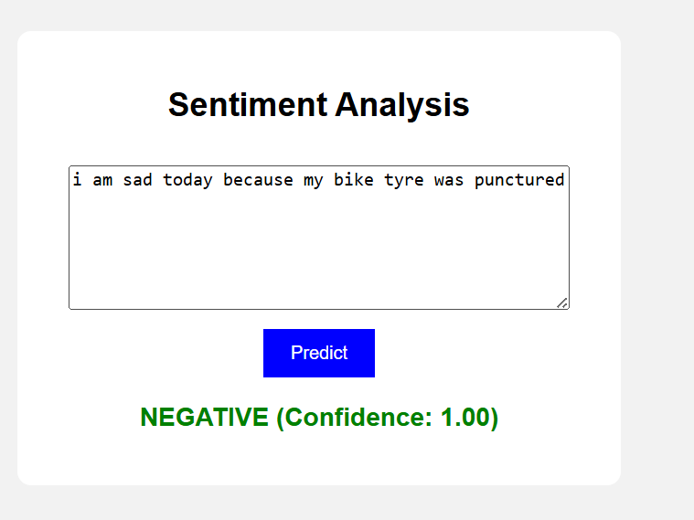

Figure 2: In this example, the user entered a sentence that includes the word 'not sad'. The model understood the context and predicted the sentiment as POSITIVE with a confidence score of 0.98.

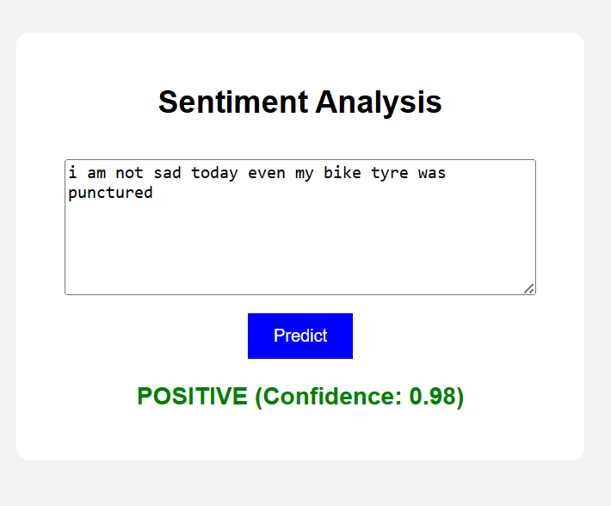

7. Libraries

flask: Used to create a web interface where users can enter text and view sentiment results.
transformers: Used to load the pre-trained Hugging Face model for sentiment analysis.
torch: Used as the backend framework to run the pre-trained deep learning model.
pipeline (from transformers): Used to simplify loading and using the sentiment analysis model in one line.

8. Conclusion
This assignment shows that pre-trained models are very useful and save a lot of time. We did not need to train a model from the beginning, but we were still able to build a working sentiment analysis system. The system gives results quickly, provides good accuracy, and is easy for users to use.

____________________________________

